# Project Design Phase-II

**Data Flow Diagram & User Stories**

|  |  |
| --- | --- |
| Date | 19 October 2022 |
| Team ID | PNT2022TMID46979 |
| Project Name | Project – Smart Fashion Recommender |
| Maximum Marks | 4 Marks |

**Data Flow Diagrams:**

A Data Flow Diagram (DFD) is a traditional visual representation of the information flows within a system. A neat and clear DFD can depict the right amount of the system requirement graphically. It shows how data enters and leaves the system, what changes the information, and where data is stored.

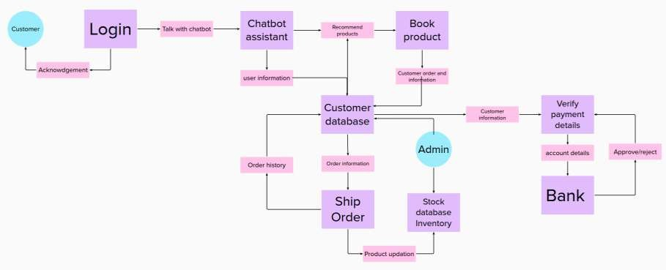

**User Stories**

Use the below template to list all the user stories for the product.

|  |  |  |  |  |  |  |
| --- | --- | --- | --- | --- | --- | --- |
| **User Type** | **Functional Requirement (Epic)** | **User Story Number** | **User Story / Task** | **Acceptance criteria** | **Priority** | **Release** |
| Customer (Mobile user) | Registration | USN-1 | As a user, I can register for the application  by entering my email, password, and confirming my password. | I can access my account  / dashboard | High | Sprint-1 |
|  |  | USN-2 | As a user, I will receive confirmation email once I have registered for the  application | I can receive confirmation email &  click confirm | High | Sprint-1 |
|  |  | USN-3 | As a user, I can register for the application through Facebook | I can register & access the dashboard with  Facebook Login | Low | Sprint-2 |
|  |  | USN-4 | As a user, I can register for the application  through Gmail | I can access my  account/dashboard | Medium | Sprint-1 |
|  | Login | USN-5 | As a user, I can log into the application by entering email & password | I can receive confirmation email &  click confirm | High | Sprint-1 |
|  | Dashboard | USN-6 | As a user, can view the new and latest  product on the dashboard | I can receive the latest  product details | High | Sprint-2 |
| Customer (Web user) | Web Search | USN-7 | As a user, can search the product on the various websites | Happy as the customer finding the numerous  options | High | Sprint-2 |
|  |  |  | As a user, I can chat with the chatbot for  searching products |  |  |  |
|  | Orders | USN-8 | As a user, can order the product | I can receive the confirmation message when ordering the  product | High | Sprint-3 |

|  |  |  |  |  |  |  |
| --- | --- | --- | --- | --- | --- | --- |
| **User Type** | **Functional Requirement**  **(Epic)** | **User Story**  **Number** | **User Story / Task** | **Acceptance criteria** | **Priority** | **Release** |
|  | Payment | USN-9 | As a user, can cancel the product and the payment can be returned to their account | Numerous payment option like Gpay, Amazon pay.  An easy check out process | High | Sprint-4 |
|  | Refund/Return | USN-10 | As a user, can exchange the product and cancelling the product | I can receive the message when I cancel  the product and exchange the product | High | Sprint-4 |
|  | Feedback | USN-11 | As a user, can share their feedback for the  product on the feedback page | Friendly and helpful  customer support | High | Sprint-4 |
| Customer Care Executive | Help line | USN-12 | As a User, Sometimes if the any issues in my ordering product that time I will use  the customer care help line method | I solve my issues of my ordering product | Medium | Sprint-4 |
| Administrator | Data Base | USN-13 | As the Admin, I can check out the database about the stock and have a track of all the things that the users are purchasing. | I can check out the database about the stock and have a track of all  the things that the users are purchasing. | High |  |